Highcliffe School Student Bulletin

Monday 11th - Friday 15th December 2006: Week B

Thought For The Week:
The future depends on what we do in the present. - Mahatma Gandhi


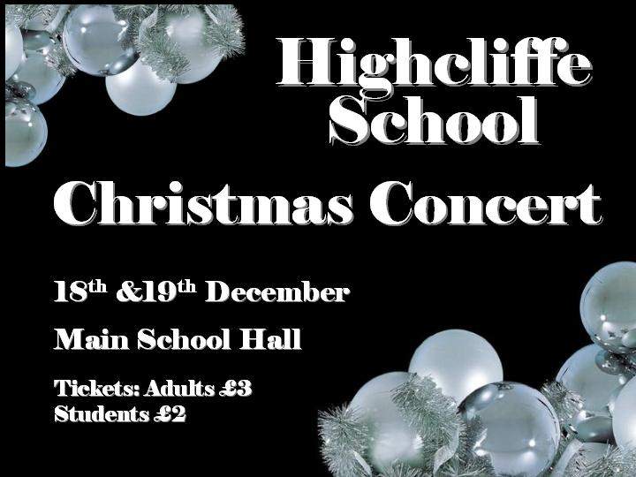

Christmas Lunch: The School Christmas Lunch will be on Thursday 14th December.

Notice for Year 9: If you are hoping to come to the History Evening this Thursday please return your slips to Ms Barrall. It will be your only opportunity to see all the great reconstructions of the trenches and PowerPoints that have been produced. Light refreshments, a quiz and a raffle are on offer.

S-Factor this Thursday: Shadow box theatre finishing off, presentations & prizes awarded. This will be the last S-Factor of this term. Watch out for the Spring term S-Factor booklet and S-Factor extra starting in January.
The First movie will be: Osmosis Jones! All year 7, 8 & 9 students welcome! Are you brave enough?

Last Chance to cash in merits this term!
Monday, Tuesday & Wednesday
this week in the Library.
Last date for cashing in merits this term:
Wednesday 13th December!

Merit Assemblies: Year 7, 8 & 9 students – look out for the merits assembly at the end of term. Lots of prizes to be won! The more merits you have cashed in, the more chance you have of winning!
Mobile phone recycling campaign - please make an effort to bring in any unused handsets into school before the end of term. Remember to remove the SIM card! Put them in an envelope and pass to your tutor please. Each phone will raise approximately £5 for the school charity bank and 50p goes automatically to Oxfam. Thank you. Mrs Finch.

Year 10: Christchurch Borough Council are running a Work experience logo competition that all Year 10's are invited to enter. The objective is to produce a logo the Employers would be proud to display on their headed paper to show that they support Work Experience in the Christchurch area. All designs are to be on A4 paper, and capable of being scaled down to 3cm x 3cm max. The designs must also be in black and white and convey support for work experience. They can include wording such as, 'supporting work experience'. All designs to be handed in to Mrs Finch by 5th January 2007. Winner gets £30 book tokens and £100 for the school! Further details from Mrs Finch.

Year 10 - all students who have paid their deposits for the Humanities trip to Berlin in May 2007 have a confirmed place on the trip. Further correspondence will follow in the New Year. Thank you for your interest – Mrs Finch.

SPORTS NOTICES Results:

Year 7 basketball v St Peters - won 18-2
Years 10/11 basketball (A) v St Peters (A) - won 18-2
Years 10/11 basketball (B) v St Peters (A) - won 14-12
Year 8 basketball v St Peters (A) - won 18-4
Year 8 basketball v St Peters (B) - won 14-8
Year 9 basketball v St Peters (A) - won 10-0
Year 7 football v Year 8 football - drew 2-2

MUSIC NOTICES
Monday after school: Guitar group for the Christmas concert in EX2 3.20-4.30pm
Tuesday after school: Harmonious Funk Jazz Band in EX3 3.20-5.00pm
Wednesday after school: Vocalis vocal group in EX2 3.20-5.00pm
Thursday lunchtime: Theory Workshop EX3 1.40-2.10pm
Thursday after school: Full chorus rehearsal for CAN’T STOP THE BEAT in EX4 3.20 – 5.00pm

Friday lunchtime: Guitar group for the Christmas concert in EX2 1.40-2.10pm

Wednesday 13th December: carol singing in Saxon Square periods 1-4 for those in the choir. Make sure that you have returned your permission slips…

BRAIN TEASER
Picture a regular (analog) clockface — with the numerals 1 to 12 correctly positioned. Where would you draw a straight line to split the clockface in half in such a way that the sum of the numbers on one side of the line will equal the sum of the numbers on the other side of the line?
Answers to be submitted with your name and tutor group in the Brain Teaser box in Ma6.

ENLIGHTENING ECO FACT - Calling all couch potatoes!
FACT: 6- to 16-year-olds in the UK spend on average three hours a day watching TV, compared to just two hours average across Europe. A TV-free week could create 21 extra hours for you to have a laugh in, plus you'll use less electricity too so be helping save the planet!
With Christmas coming up how about you get creative and make some cards or gifts, or brave the rain and make the most of the daylight hours outside!

